Anchor Club T-shirt Fundraiser
Pre-Order Only
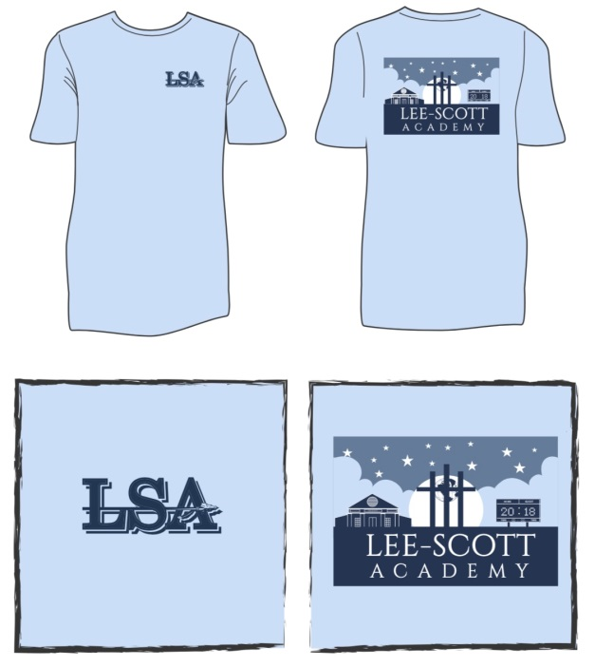
“Chambray Comfort Color” with Navy/Slate/White
Adults $20, Youth $15 Adult Long Sleeve $25

*Name: __________________________________________

*Grade: ________________*Teacher: _________________

Chambray  “Lee-Scott” | Short Sleeve $20 |  | Long Sleeve $25 (Adults*) | Total | Cash/Check
Adult Sizes | Quantity |  | Quantity
3XL
2XL
XL
L
M
S
Youth Sizes | Quantity
YL |  |  | N/A
YM |  |  | N/A
YS |  |  | N/A
*Make Checks | To LSA* |  | *Return to | Upper School | Office*

Orders due by Wednesday, September 12th

